457.557 Water Resources Systems Engineering, Spring 2022
Assignment #1
Due before the lecture of Mar-22, 2022
(석사과정-한/영 중 선택, 박사과정-영어 작성)

- Lec 01에서 소개한 23개의 Unsolved Problems in Hydrology (UPH) 중 가장 중요하다고 생각되는, 혹은 가장 시급히 해결되어야 한다고 생각되는 질문은 무엇인가요? 각기 다른 Topic에서 최소 3개의 질문을 선택한 후, 다른 질문들보다 더 중요하다고 생각한 이유(혹은 먼저 해결되어야 한다고 생각하는 이유)를 3개의 질문에 대해 각각 한 문단정도로 적어주세요. 만약 제시된 23개의 문제 이외로 더 중요하다고 생각하는 문제가 있으면 새롭게 제시해 주세요.

- What is the difference between Integrated Water Resources Management (IWRM) and Sustainable Water Resources Management? Identify the steps of IWRM frequently applied in Korea. How are they interconnected with each other?

- Find and present the following statistics from the textbook or the Internet.
  - Percent of all freshwater resources worldwide available for drinking;
  - Number of people who die each year from diseases associated with unsafe drinking water;
  - Percent of total freshwater resources in polar regions;
  - Per capita annual withdrawal of cubic meters of freshwater in US/South Korea;
  - Average world per capita annual withdrawal of cubic meters of freshwater;
  - Tons of pollutants entering lakes and rivers daily in various regions;
  - Average number of gallons of water consumed by humans in a lifetime;
  - Average number of kilometers per day a woman in a developing country must walk to fetch fresh water.

- Create a reservoir model on Boryeong Dam by following the steps below:
  - Conduct a preliminary analysis on the target reservoir. Write a short paragraph (with your own words) regarding the target reservoir including the general information of the reservoir and the nearby basins. You may include figures or tables if they help you to explain.
  - What is special regarding the reservoir? How severe was the disaster the reservoir had to undergo recently? Write a short paragraph that describes the recent status of the reservoir.
  - Download the observation data of the reservoir from: https://www.water.or.kr/.
Click on 운영 현황-댐/보수문자료-수문자료-다목적댐-보령-댐현황 이전 자료받기.
Your data should be the DAILY observation data from 1998-01-01 through 2017-12-31.
  - Organize the data so that they are in the correct order. Click on 일시 (Cell B3). Then, click on 데이터-필터-텍스트 오름차순 정렬. Check if your data is in the correct order from 1998-01-01 through 2017-12-31.
  - Among the data, this time you will only use the following data:
(1) 저수량(백만m3), (2) 유입량 (m3/s), and (3) 총방류량 (m3/s) along with the date.
Copy only the columns in B, E, H, and K into another file named “BR_Simulation.xlsx” under the Sheet named “BR_Data”.
  - Before moving on to the next step, transform the data in Column B from text into numbers.

- You will create a daily model of Boryeong Dam in Microsoft Excel by following the steps below:
  - First, extract the inflow data between 2016-10-01 through 2017-09-30. Save the data into another sheet named “2017_WY_Sim.” Transform the scale of the inflow into MCM (Million cubic meters) in Column H.
(Please note the scale of the storage is different from the inflow and the outflow in BR_Data Sheet)
  - Transform the monthly demand data of Boryeong Dam into MCM. Roughly, the aggregate demand of Boryeong Dam should be 100 MCM annually.
  - Using the “vlookup” function in Excel, create a column with daily demand corresponding to each month. Check if your demand changes in June.
  - Assume that no matter what, release is equal to demand (보령댐 기본계획공급량) and run a simulation of Boryeong Reservoir according to the flow diagram. What are the problems you observe? When is the first time your model observes negative storage?
  - In order to prevent the negative storage problem, modify your model so you’re your model satisfy the feasibility constraints (Smin $≤$ St $≤$ Smax)
(Hint: use Min/Max functions in Excel)
  - Re-calculate actual release that satisfy the feasibility constraints and the continuity equations. Check if your model meets the annual mass balance equation (Total Inflow + Starting Storage = Total Actual Outflow + Final Storage). What is the sum of the left-hand side equation? Right-hand side of the equation? (They should be very much similar to each other)
  - Finally, refer to the following <용수공급조정기준> that are being applied to all reservoirs in Korea. The main concept of <용수공급조정기준> (hedging) is in reducing the release prior to low storage. How do you think the implementation of hedging rules during operation affect the performance of the reservoir? Why do you think like that?
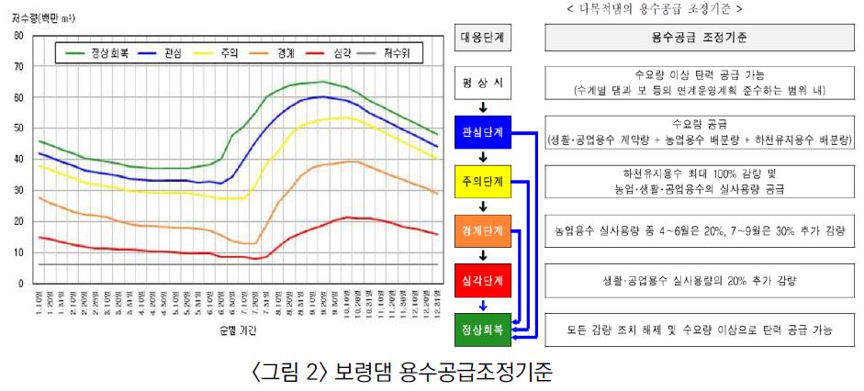

  - Simply, in order to observe the effect of hedging, create a model that reduces release by 50% when the storage falls below 25 MCM. Draw a graph that compares the release and storage of Boryeong Dam with and without hedging. Do your assumptions made in G follow the conclusions made from the simulations in H?
  - What are the key assumptions you made in building the model? List at least three key assumptions inside the model.
  - How will you enhance the model’s practicality?
(어떻게 모델을 더욱 현실과 비슷하게 개선할 것인지?)

